**2.Display future leap years from current year to a final year entered by user.**

s=int(input("Enter the start year : "))

e=int(input("Enter the end year : "))

if(s<e):

print("leap year are : ",end="")

for i in range(s,e):

if i%4==0 and i%100!=0:

print(i,end=" ")

**OUTPUT**

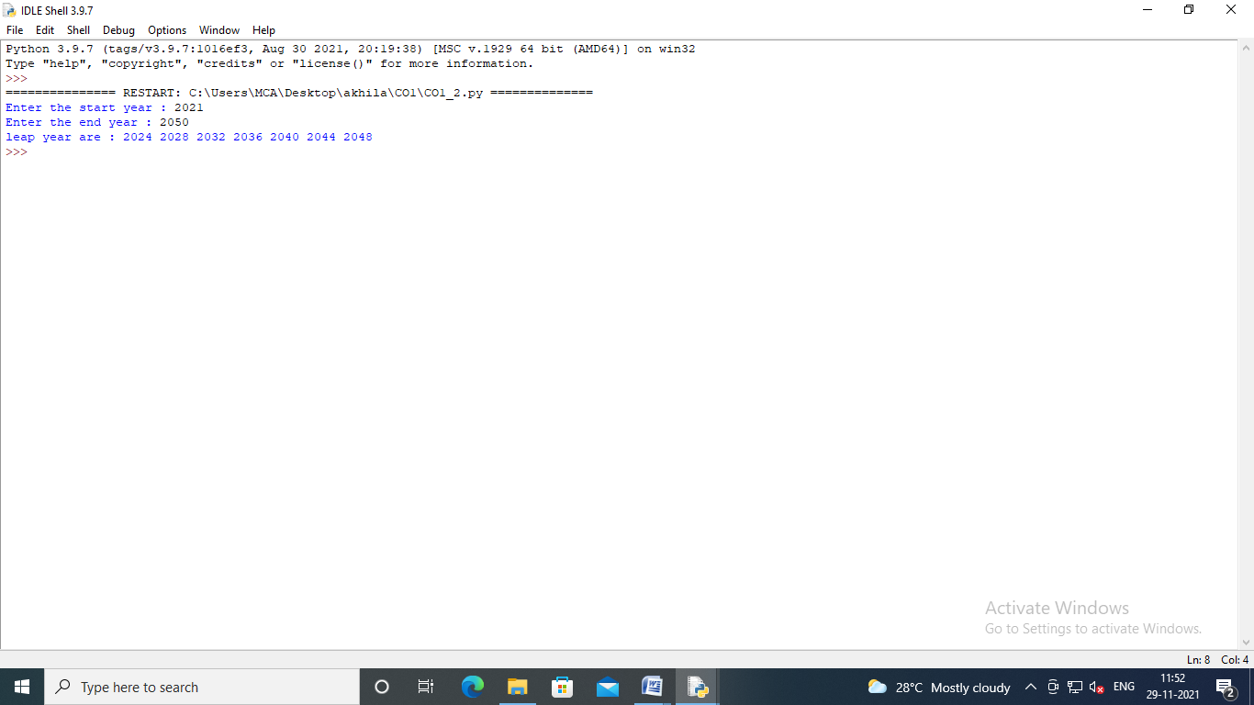

**3.List comprehensions:**

* **Generate positive list of numbers from a given list ofintegers**
* **Square of Nnumber**
* **Form a list of vowels selected from a givenword**

print("Generate Positive List of Numbers From A given List Of Integers")

list1=[-10,20,-30,40,-50,60,-70,80,-90,100]

re = [num for num in list1 if num>=0]

print(re)

list1 = []

print(sep='\n')

print("SQUARE NUMBERS")

n = int(input("Enter the Limit : "))

for i in range(1,n+1):

sq=i*i

list1.append(sq)

print("Square Numbers are : ",list1)

print(sep='\n')

print("PRINT VOWELS IN A GIVEN WORD")

word = str(input("Enter the word : "))

print("WORD is : "+word)

print("Vowels are : ")

for i in word :

if i in 'aeiouAEIOU':

print([i])

print(sep='\n')

print("PRINT ORDINAL VALUES")

w = str(input("Enter the word "))

print("WORD IS : " +w)

print("ORDINAL VALUES ARE ")

for i in w:

print(i,end=":")

print(ord(i),end=" ")

**OUTPUT**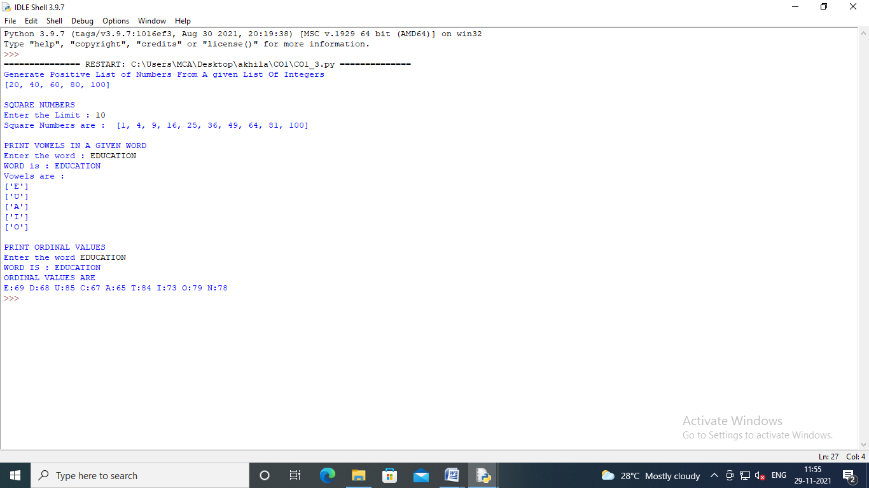

**4.Count the occurrences of each word in a line of text.**

str1=input("Enter a string : ")

wordlist=str1.split()

count=[]

for w in wordlist:

count.append(wordlist.count(w))

print("Count of occurance "+str(list(zip(wordlist,count))))

**OUTPUT**

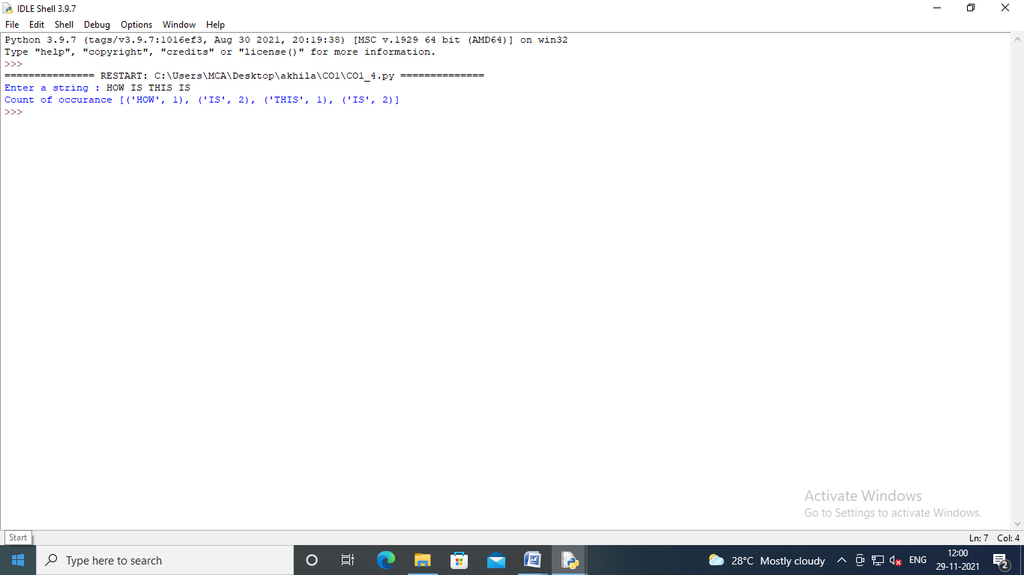

**5.Prompttheuserforalistofintegers.Forallvaluesgreaterthan100,store‘over’ instead.**

n =[]

s = int(input("Enter the Limit : "))

print("Enter {s} values ")

for i in range(0,s):

n.append(int(input()))

print("Final list")

for i in range(0,len(n)):

if n[i]>=100:

print("over")

else:

print(n[i])

**OUTPUT**

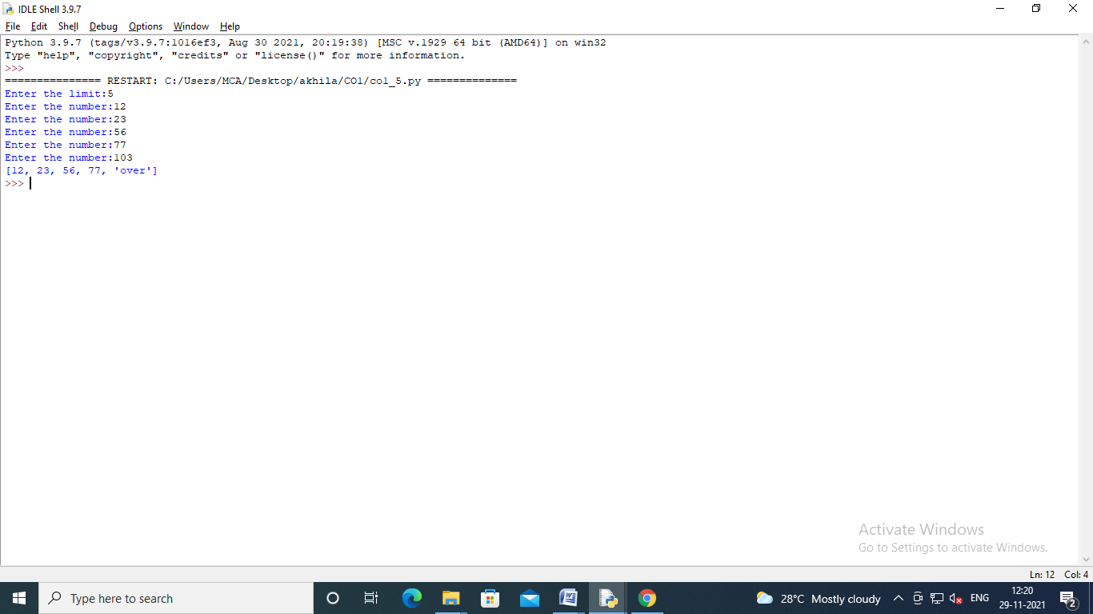

**6. Store a list of first names. Count the occurrences of ‘a’ within the list**

list1=["apple","mango","apple"]

occ = list1.count("apple")

print("Count occurance of apple : " ,occ)

**OUTPUT**

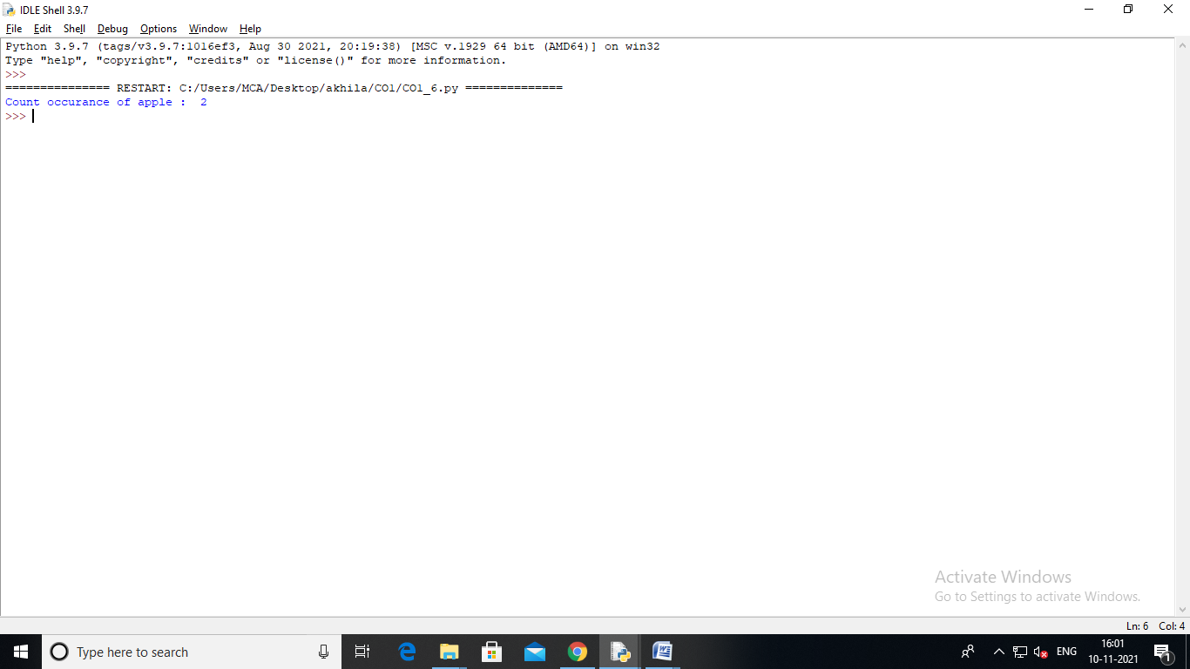

**7. Enter 2 lists of integers. Check (a) Whether list are of same length (b) whether list sums to same value (c) whether any value occur in both**

lst=[1,3,5,7,9,11,34]

lst1=[5,13,45,7,20,65,1]

s=int(0)

c=int(0)

if len(lst)==len(lst1):

print("Lists are of same length")

else:

print("Lists have different length")

for i in range(0,len(lst) and len(lst1)):

s=s+lst[i]

c=c+lst1[i]

if(s==c):

print("Equal sum")

else:

print("Not same sum")

print("Elements that matched are:")

l=[]

for i in range(0,len(lst)):

for j in range(0,len(lst1)):

if lst[i]==lst1[j]:

l.append(lst[i] and lst1[j])

else:

continue

print(l)

**OUTPUT:** 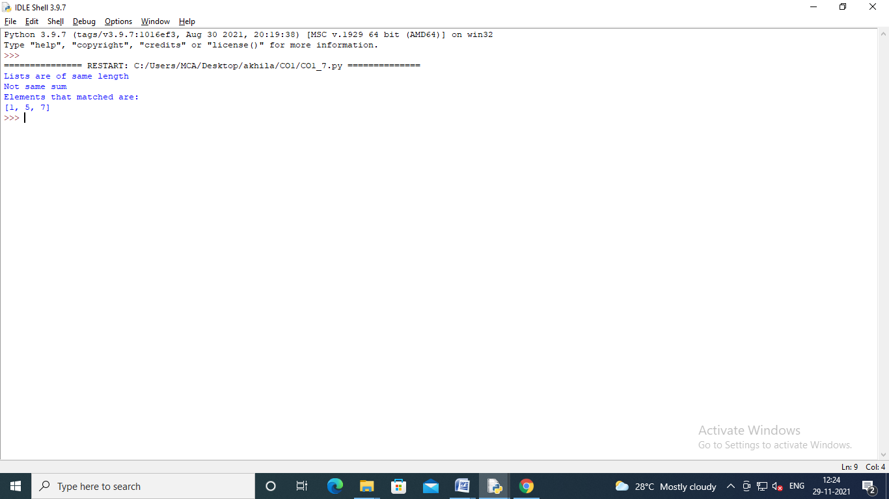

**8.Get a string from an input string where all occurrences of first character replaced with ‘$’, except first character. [eg: onion ->oni$n]**

str1 = input("Enter a String : ")

char = str1[0]

str1=str1.replace(char,'$')

str1 = char + str1[1:]

print(str1)

**OUTPUT**

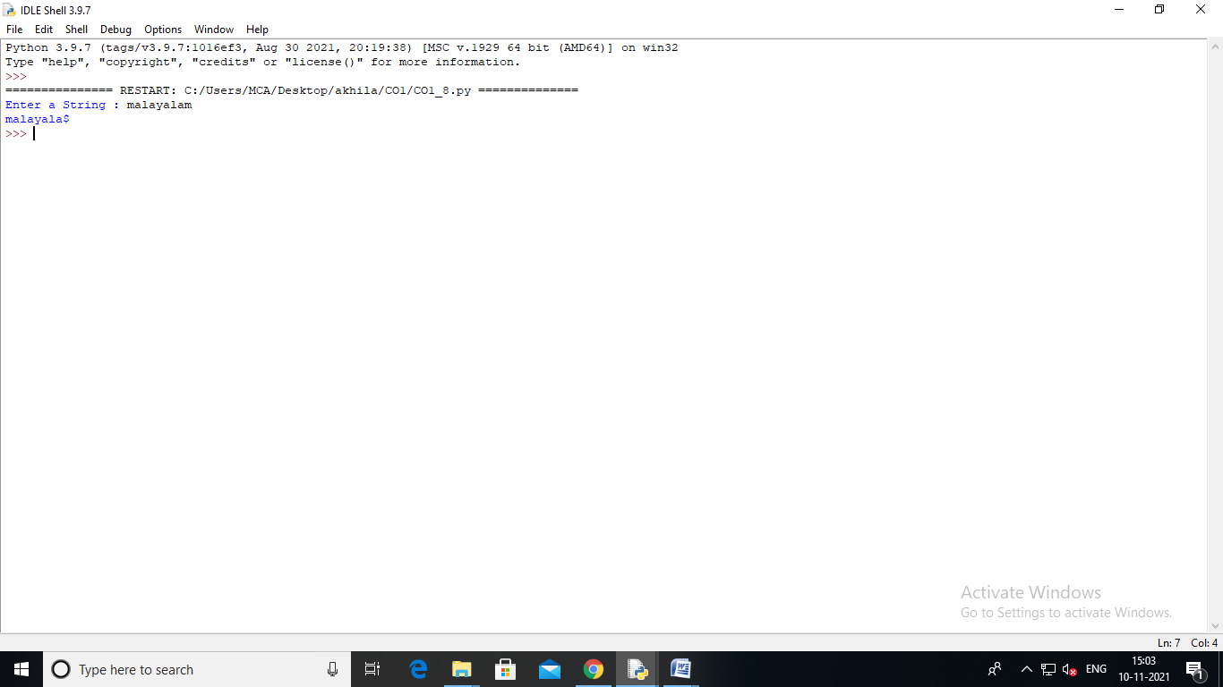

**9.Create a string from given string where first and last characters exchanged. [eg: python ->nythop]**

str = input("Enter the string : ")

new_str = str[-1:] +str[1:-1] + str[:1]

print("New String ",new_str)

**OUTPUT**

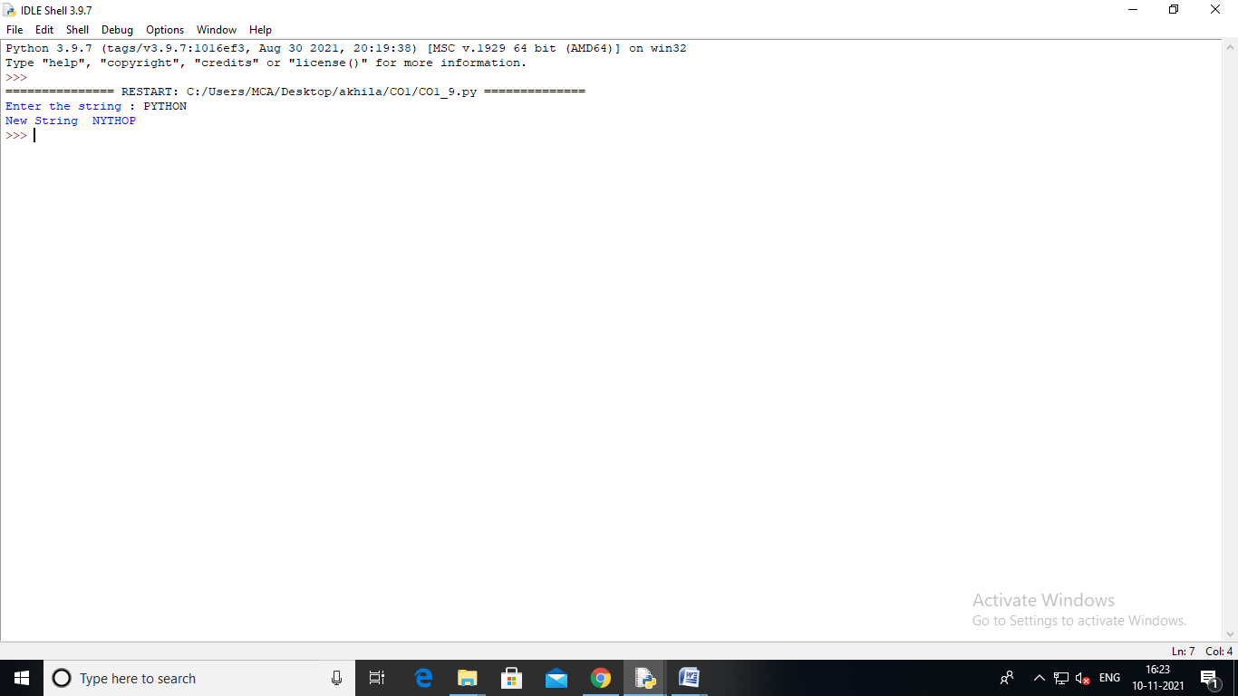

**10.Accept the radius from user and find area of circle.**

print("Area of Circle")

r = float(input("Enter the radius of circle: "))

result = 3.14 * r * r

print("Area of circle is " ,result)

**OUTPUT**

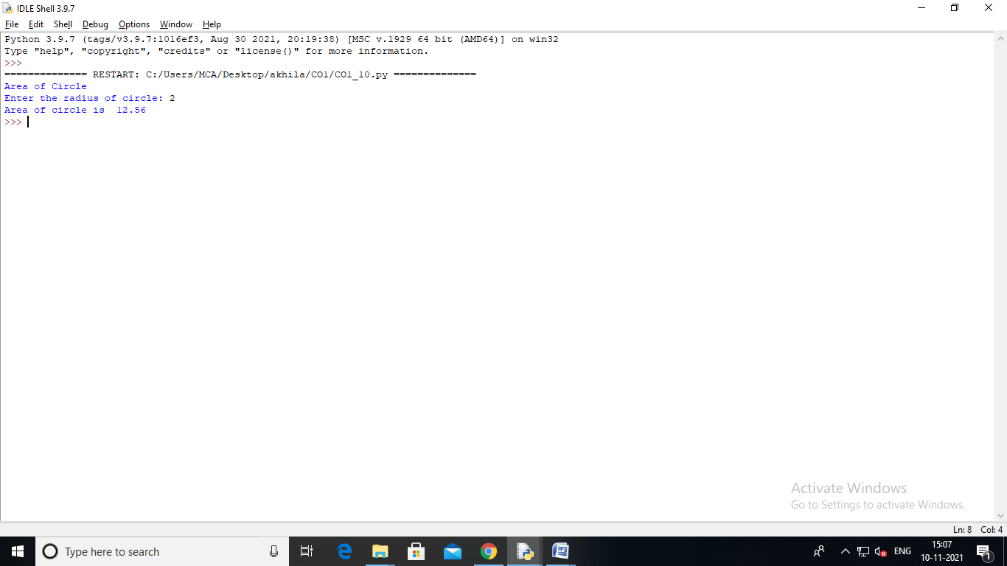

**11. Find biggest of 3 numbers entered**

**OUTPUT**

x = int(input("Enter the First Number : "))

y = int(input("Enter the Second Number : "))

z = int(input("Enter the Third Number : "))

if(x>y):

if(x>z):

print("Largest is First Number : ",x)

else:

print("Largest is Third Number : ",z)

else:

if(y>z):

print("Largest is Second Number : ",y)

else:

print("Largest is Third Number : ",z)

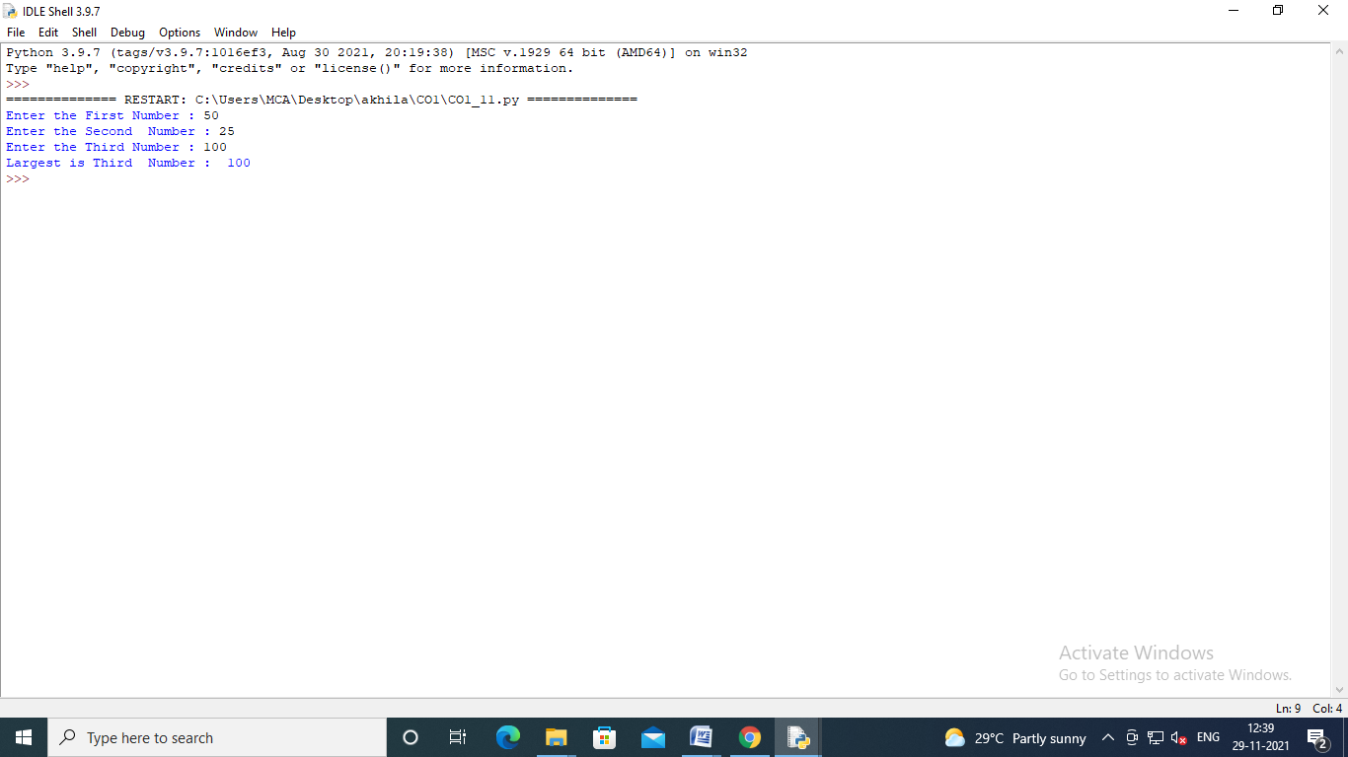

**12.Accept a file name from user and print extension of that**

file = input("Enter the file name :")

f = file.split(".")

print("Extension of the file is : " + f[-1])

**OUTPUT:**

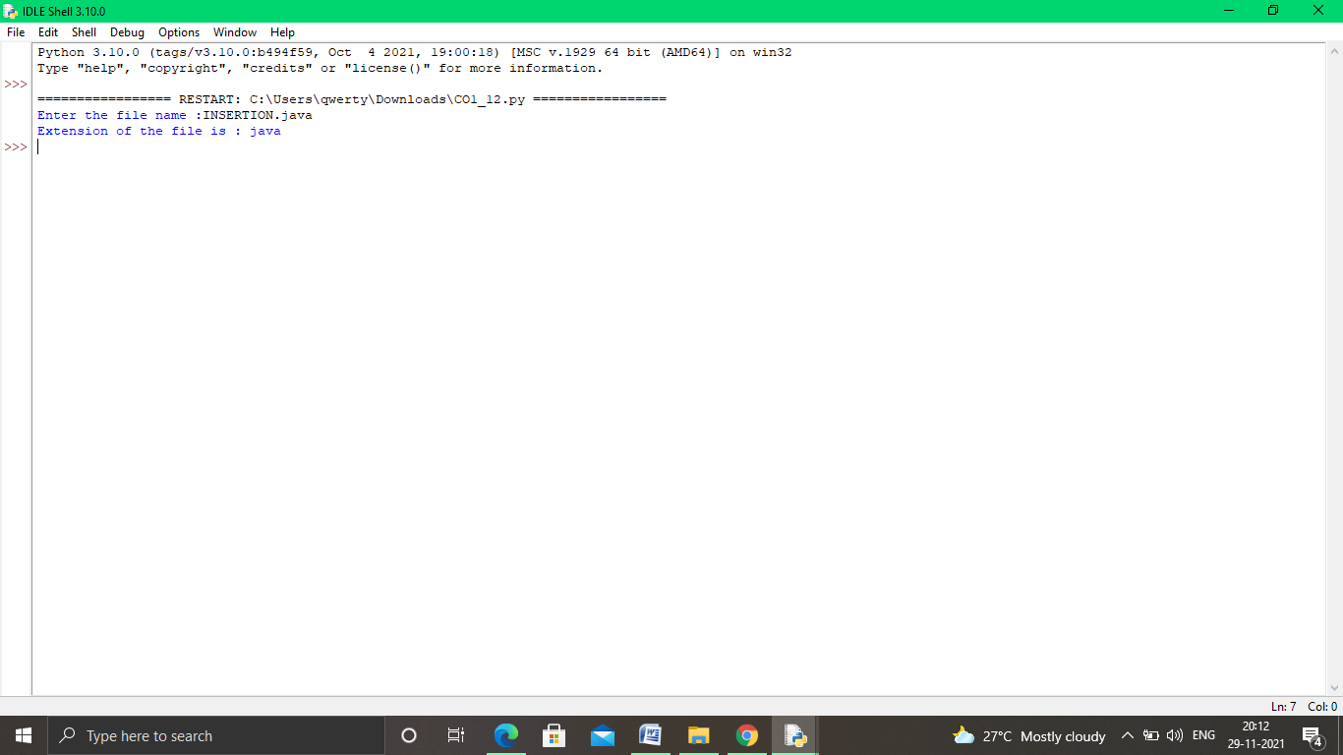

**13.Create a list of colors from comma-separated color names entered by user.Display first and last colors.**

a=[]

n=int(input("Enter the limit : "))

for i in range(n):

b=input("Enter the color :")

a.append(b)

print(a)

print("First color : " ,a[0])

print("Last color: ",a[n-1])

**OUTPUT :**

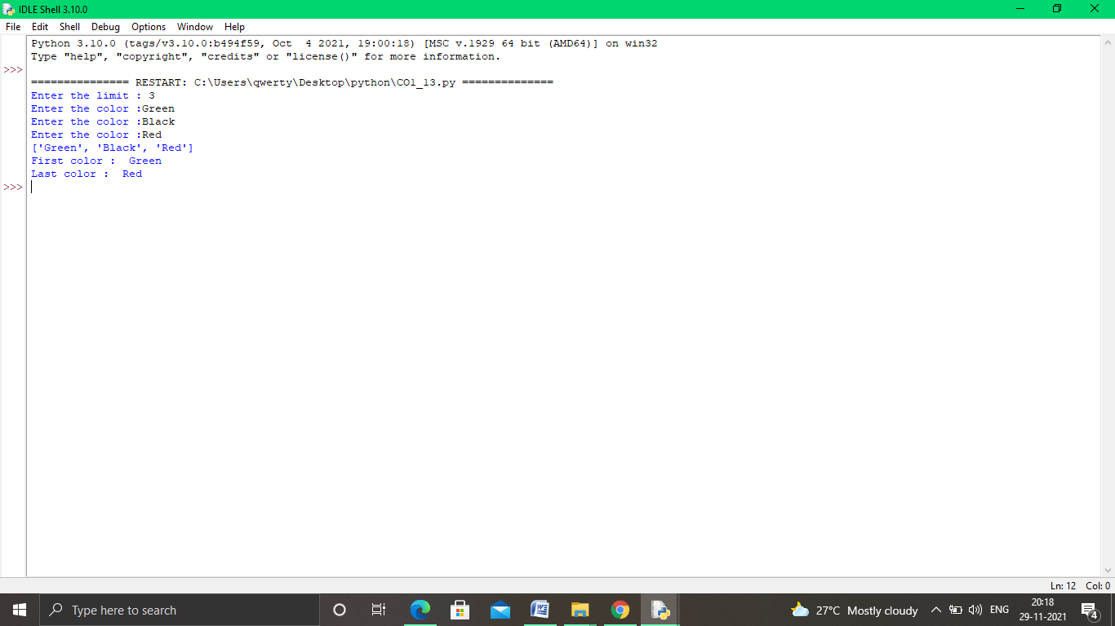

**14.Accept an integer n and compute n+nn+nnn**

n = int(input("Enter a number : "))

x = int( "%s" % n )

y = int( "%s%s" % (n,n) )

z = int( "%s%s%s" % (n,n,n) )

print ("n + nn + nnn :",x+y+z)

**OUTPUT:**

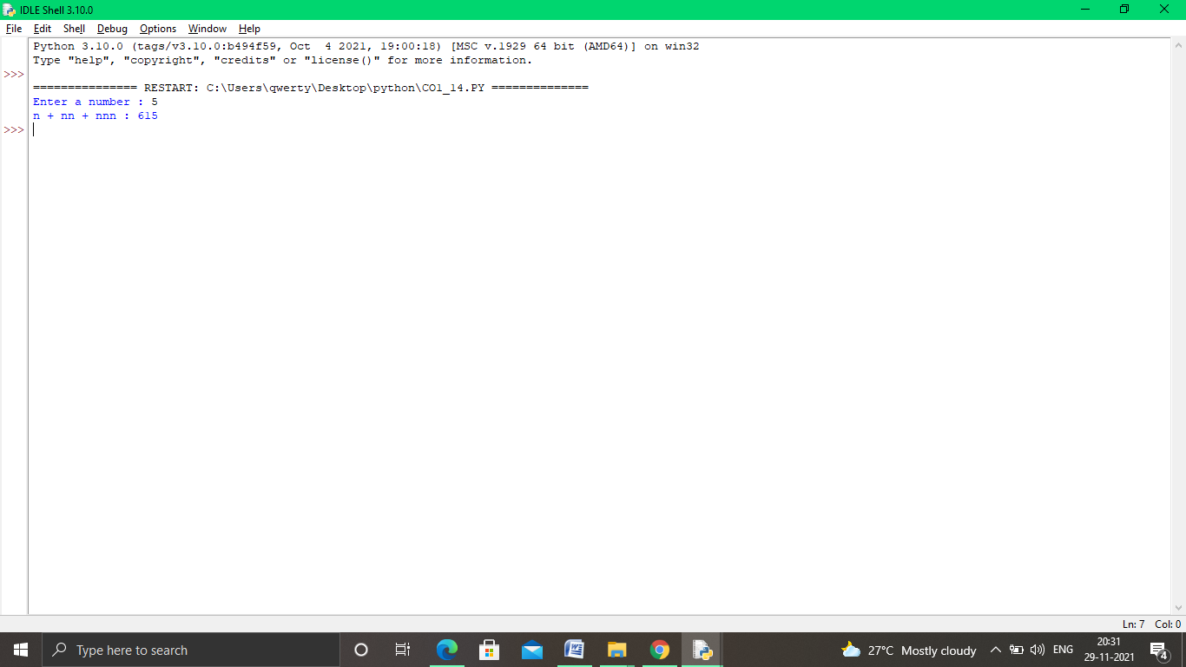

**15.Print out all colors from color-list1 not contained in color-list2**

color_list1=set(['red', 'green' , 'black'])

color_list2=set(['black' , 'white' ,'orange'])

print(color_list1.difference(color_list2))

**OUTPUT :**

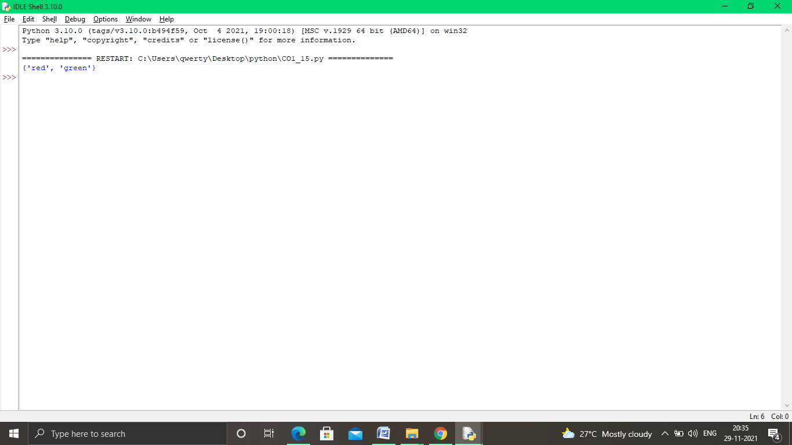

**16.Create a single string separated with space from two strings by swapping the character at position 1**.

a = "python"

b = "java"

p1 = a[0]

p2 = b[0]

c = b[0] + a[1 : len(a)] +" "+a[0] + b[1 : len(b)]

print(c)

**OUTPUT**

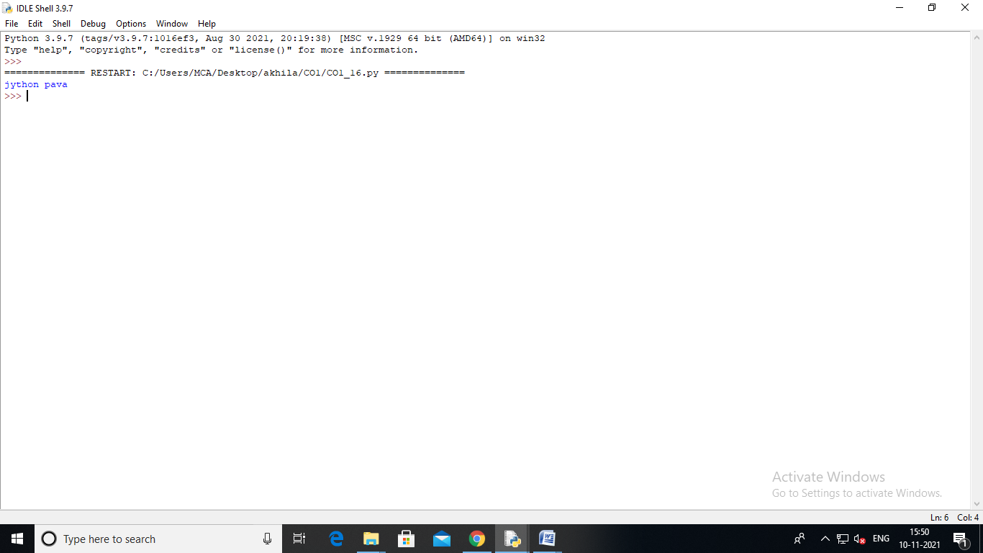

**17. Sort dictionary in ascending and descending order.**

import operator

d={1:2,3:4,4:3,2:1,3:1}

print("ORIGINAL DICTIONARY",d)

sorted_d=sorted(d.items(),key=operator.itemgetter(1))

print("DICTIONARY IN ASCENDING ORDER : ",sorted_d)

sorted_d=dict(sorted(d.items(),key=operator.itemgetter(1),reverse=True))

print('DICTIONARY IN DESCENDING ORDER : ',sorted_d)

**OUTPUT:**

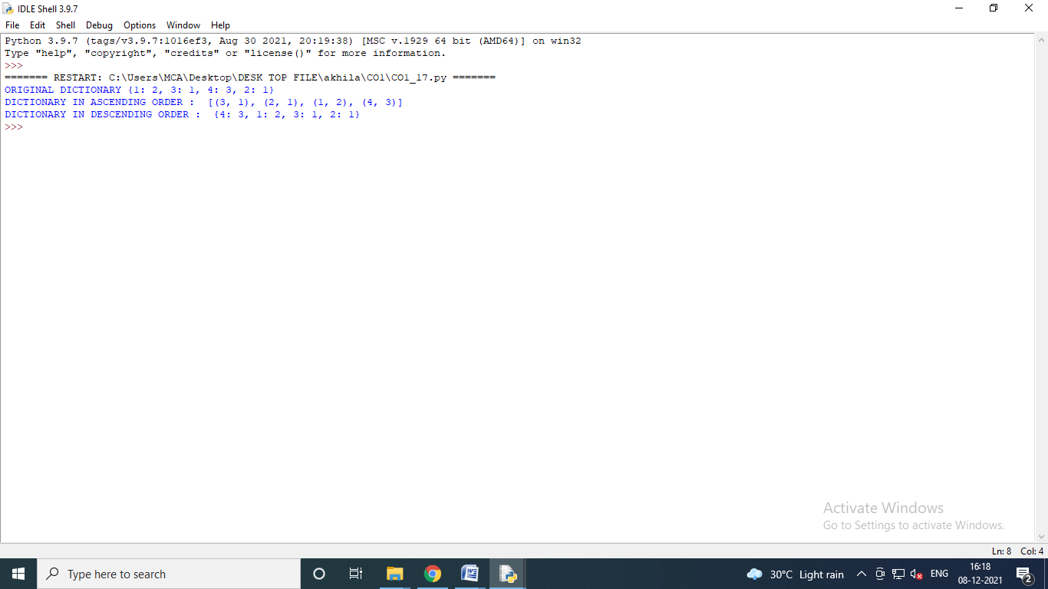

**18.Merge two dictionaries**

d1={'a':100,'b':200}

d2={'x':300,'y':400}

print("DICTIONARY 1 :",d1 )

print("DICTIONARY 2 : ",d2)

d=d1.copy()

d.update(d2)

print("DICTIONARY MERGE : ",d)

**OUTPUT:**

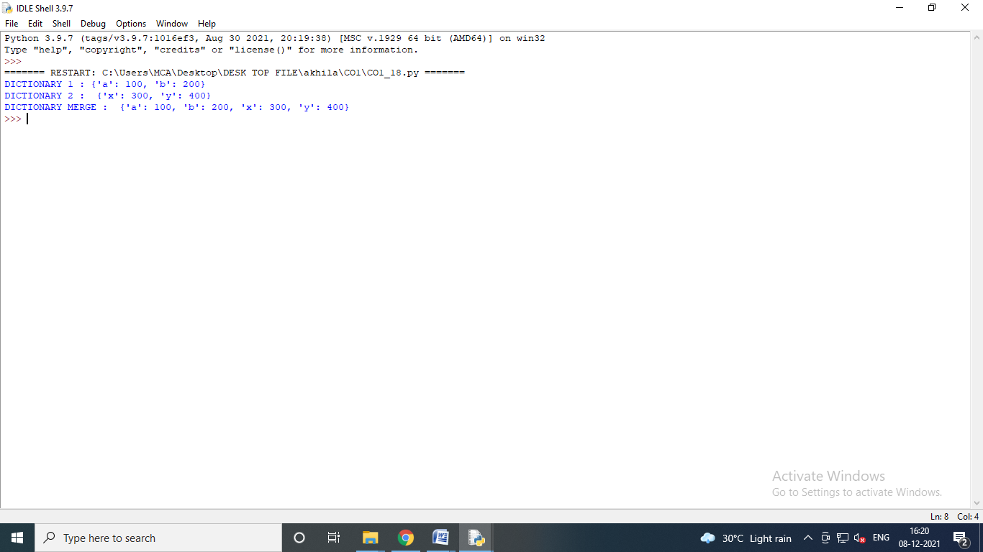

**19.Find gcd of 2 numbers.**

x = int(input("Enter the value of X : "))

y = int(input("Enter the value of Y : "))

i=1

while(i<=x and i<=y):

if(x%i==0 and y%i==0):

gcd=i

i=i+1

print("GCD",gcd)

**OUTPUT**

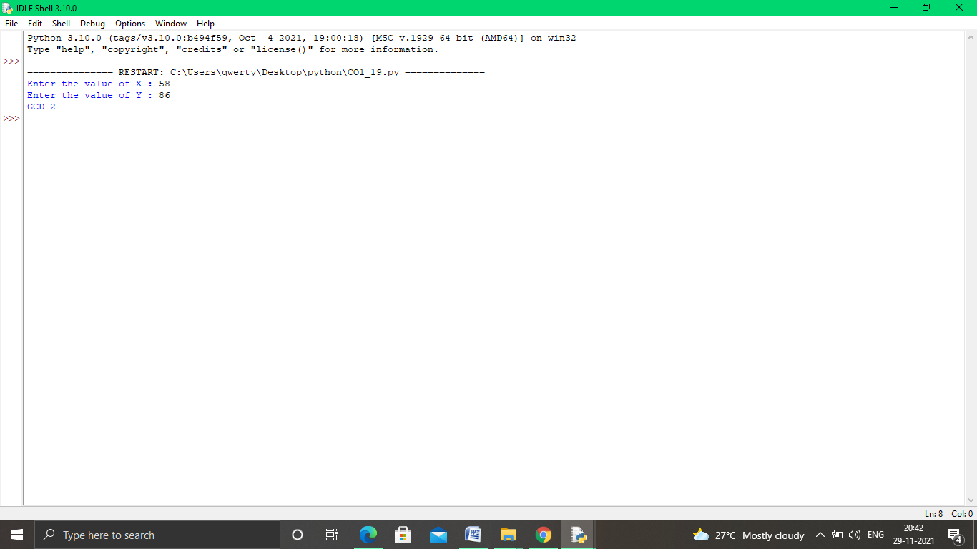

**20.From a list of integers, create a list removing even numbers.**

num=[1,2,3,4,5,6,7,8,9,10]

print("Original list",num)

num=[x for x in num if x%2!=0]

print("List after removing even numbers are :",num)

**OUTPUT:**

